Noosa Robotics Academy Day – Friday April 26 (Week 1 Term 2) – Cost : Nil

Robocoast & Peregian Digital Hub would like to invite you to take part in an exciting opportunity to develop student and teacher’s skills in building and programming EV3 Mindstorms robots. On Friday April 26 2019, our award winning Sunshine Coast robotics group will hold an EV3 Robotics immersion day at Noosaville State School.

The event is open to all schools, colleges, students and their staff. This robotics academy day is free aind is aimed at school groups looking for a way to start their robotics program or club. Ideally school groups would arrive with an EV3 robot, USB cable and laptop, between every 2 students and bring no more than 10 students per session. We will be able to confirm final numbers after each school has responded whether they are attending or not. A separate session is available for more advanced students and staff which would include line following, colour switch blocks, variables, wired sensors and acceleration. See booking form below.

Date | Friday April 26 2019
Venue | Noosaville State School
Proposed Schedule  for beginner session | 9.30 am Welcome and Principal’s address  9.45 am Meet the RoboKings and RoboGems and hear a RoboCoast success story  10.00 am How to build a basic EV3 Riley Rover Robot with claw, ultra-sonic & light sensors  10.30 am Morning tea break (BYO)  11.00 am How to drive your robot and use its sensors  11.30 am Design and program a Mindstorms Sumo Robot – learn the rules  12.30 pm Lunch (BYO)  1.00 pm Practice RoboSumo competition – round robin  2.00 pm Thanks and farewell
Schools without EV3 robots | We have a limited number of spare EV3 robots and laptops available, first come, first served.  Please email Simon Richardson at srich252@eq.edu.au to book these.

This initial immersion day is aimed at training rookie school teams up to a standard that they can compete in the RoboCoast Sumo Robot Competition, pencilled in for Friday May 3 at Mountain Creek State High School. Last year this was Australia’s largest Sumo Robot Competition and is a great event for all abilities. The Sunshine Coast Robotics Competition will follow later in the year with a range of Sumo and RoboCup events, held at Good Shepherd
Lutheran College.

Please RSVP to Simon Richardson using the form below, on email srich252@eq.edu.au before Weds April 24 2019, with spare EV3 robots being allocated on a first-come-first-served basis. Images of last year’s event are here. Warning – places get booked out very quickly!

Yours sincerely,

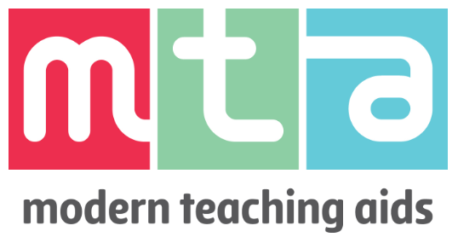
Simon Richardson
On behalf of RoboCoast
www.robocoast.tech
0409 230 228
srich252@eq.edu.au

Noosa Robotics Academy Day – Friday April 26 - Noosaville State School
REGISTRATION FORM

A confirmation email with further details about catering and a map, will be sent out after registration.

School Name:
School Contact Name:
School Contact Email:
School Contact Phone:
Basic Immersion Session | Cost: Nil
Number of students attending:
Number of staff attending:
Number of loan laptops needed:
Number of loan EV3 robots needed:
Advanced Immersion Session | A knowledge of driving and using ultrasonic and light sensors is a prerequisite – Cost: Nil
Number of students attending:
Number of staff attending:
Number of loan laptops needed:
Number of loan EV3 robots needed:

Additional Comments:

